IoT Sensors

1. Soil Moisture Sensor:
Definition: Our Soil Moisture Sensor is an advanced electronic device designed to measure the volumetric water content in the soil. It utilizes methods such as electrical resistance, dielectric constant, or neutron interaction to provide accurate moisture readings.
Use: This sensor monitors soil water content in real-time, facilitating efficient irrigation management. By ensuring that crops receive the precise amount of water needed, it helps reduce water wastage and enhances crop health and yield.
Significance: Effective irrigation is crucial for avoiding the detrimental effects of both overwatering and underwatering. Our Soil Moisture Sensor allows for precise irrigation control, optimizing water use, particularly in drought-prone areas. It also helps prevent soil erosion and nutrient leaching caused by excessive watering, promoting sustainable and productive farming practices.
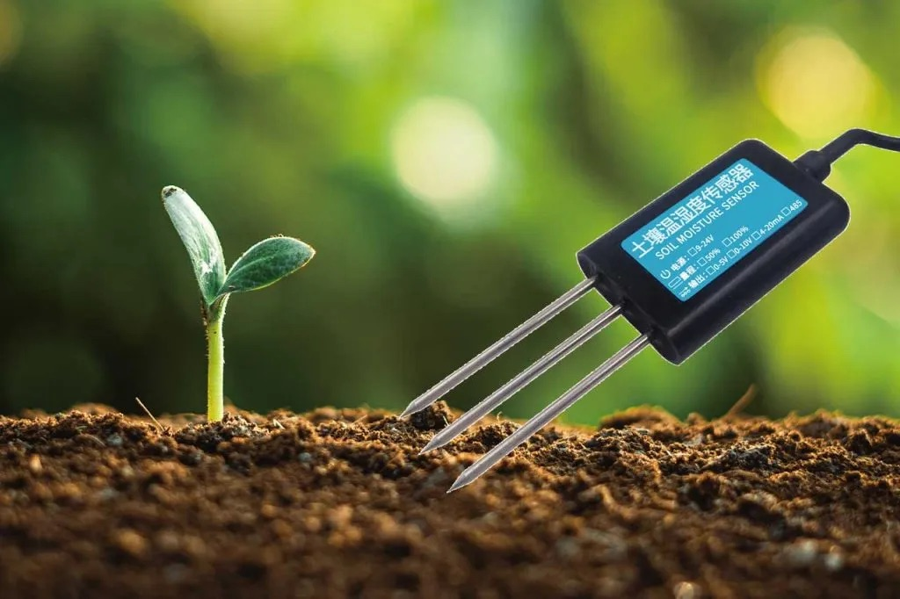

2.pH sensor:
Definition: Our pH Sensor is an advanced analytical device designed to measure the hydrogen-ion activity in soil, determining its acidity or alkalinity. Featuring a pH-sensitive electrode, this sensor produces a voltage proportional to the soil's pH level, providing precise readings.
Use: By measuring soil acidity or alkalinity, the pH Sensor helps farmers accurately apply the right amount of lime or sulfur to adjust soil pH. This ensures optimal conditions for crop growth and helps in maintaining soil health.
Significance: Soil pH influences nutrient availability and overall soil health. In acidic soils, essential nutrients like phosphorus may become less available, while toxic elements can harm plant roots. By effectively managing soil pH with our sensor, farmers can enhance crop growth, improve yield, and promote better soil management.

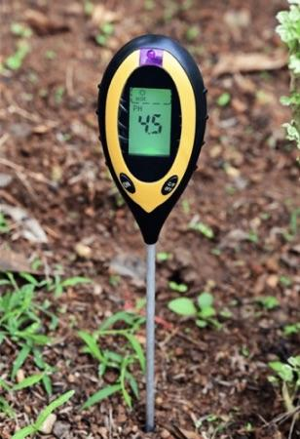
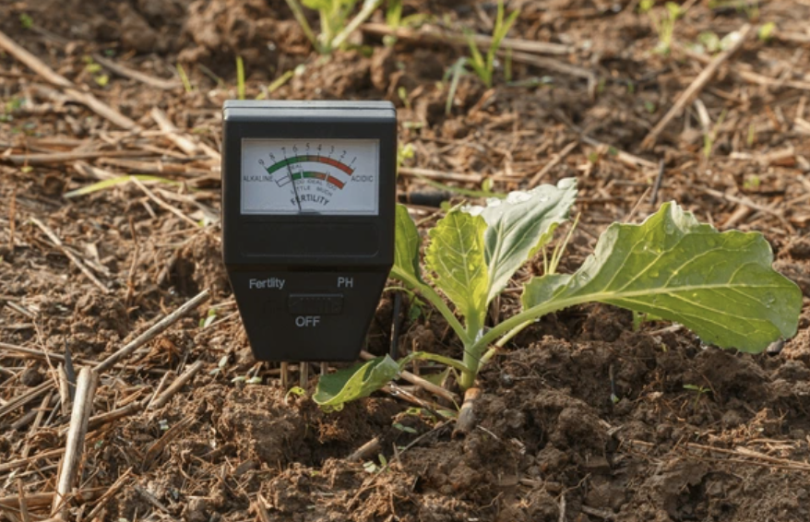

3.Nutrient Sensor:
Definition: Our Nutrient Sensor detects the concentration of essential nutrients such as nitrogen (N), phosphorus (P), and potassium (K) in the soil. Utilizing ion-selective electrodes or optical sensors, it provides accurate readings of nutrient levels.
Use: This sensor offers real-time data on nutrient concentrations, allowing farmers to apply fertilizers more precisely according to actual crop needs.
Significance: Optimizing fertilizer application is vital to prevent nutrient runoff and environmental pollution while reducing costs. Our Nutrient Sensor ensures crops receive the right nutrients at the right time, leading to improved productivity and minimized environmental impact.
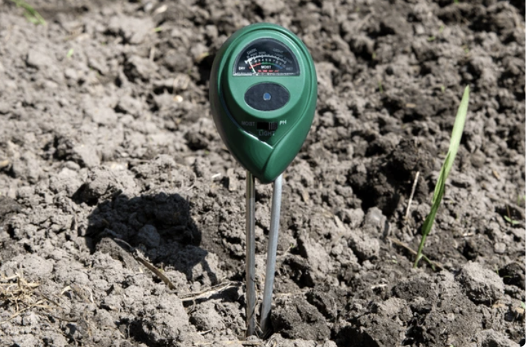

4.Temperature and Humidity Sensor:
Definition: Our Temperature and Humidity Sensor measures ambient temperature and the amount of water vapor in the air. It combines a thermistor or thermocouple for temperature measurement with a capacitive or resistive element for humidity.
Use: This sensor monitors microclimate conditions within fields or greenhouses, providing crucial data on temperature and humidity levels necessary for managing crop growth, pest control, and livestock health.
Significance: Temperature and humidity significantly impact plant growth, pest and disease management. By keeping track of these conditions, our sensor helps farmers take proactive measures to maintain optimal growing environments, ensuring healthy crops and livestock.

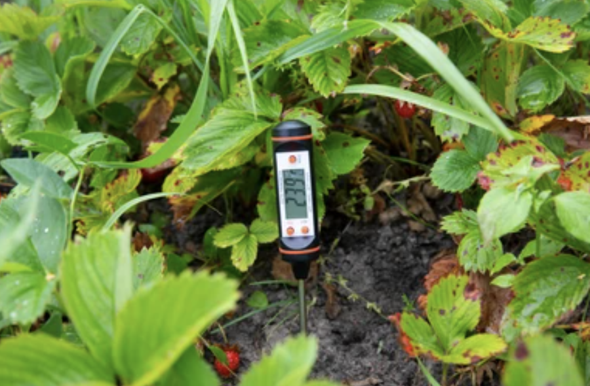

5.Digital Greenhouse CO2 Controller

Definition: Our Digital Greenhouse CO2 Controller is a cutting-edge device designed to precisely monitor and regulate carbon dioxide (CO2) levels within greenhouse environments. Featuring a large LCD display, this controller offers real-time data on CO2 concentrations and allows for accurate management of CO2 enrichment systems.

Use: Our CO2 Controller ensures that your greenhouse maintains optimal CO2 levels to boost plant growth and productivity. By continuously tracking CO2 concentrations, it helps maintain the ideal conditions for plant photosynthesis and development. The user-friendly LCD display provides clear and immediate readings, making it easy to monitor and adjust CO2 levels effectively.

Significance: Maintaining the right CO2 levels is essential for maximizing plant health and yield in a greenhouse setting. Our Digital Greenhouse CO2 Controller enables precise control over CO2 enrichment, leading to healthier plants and improved crop yields. It enhances greenhouse management by providing accurate data and facilitating better control of environmental conditions, ensuring efficient use of resources and optimal plant growth.
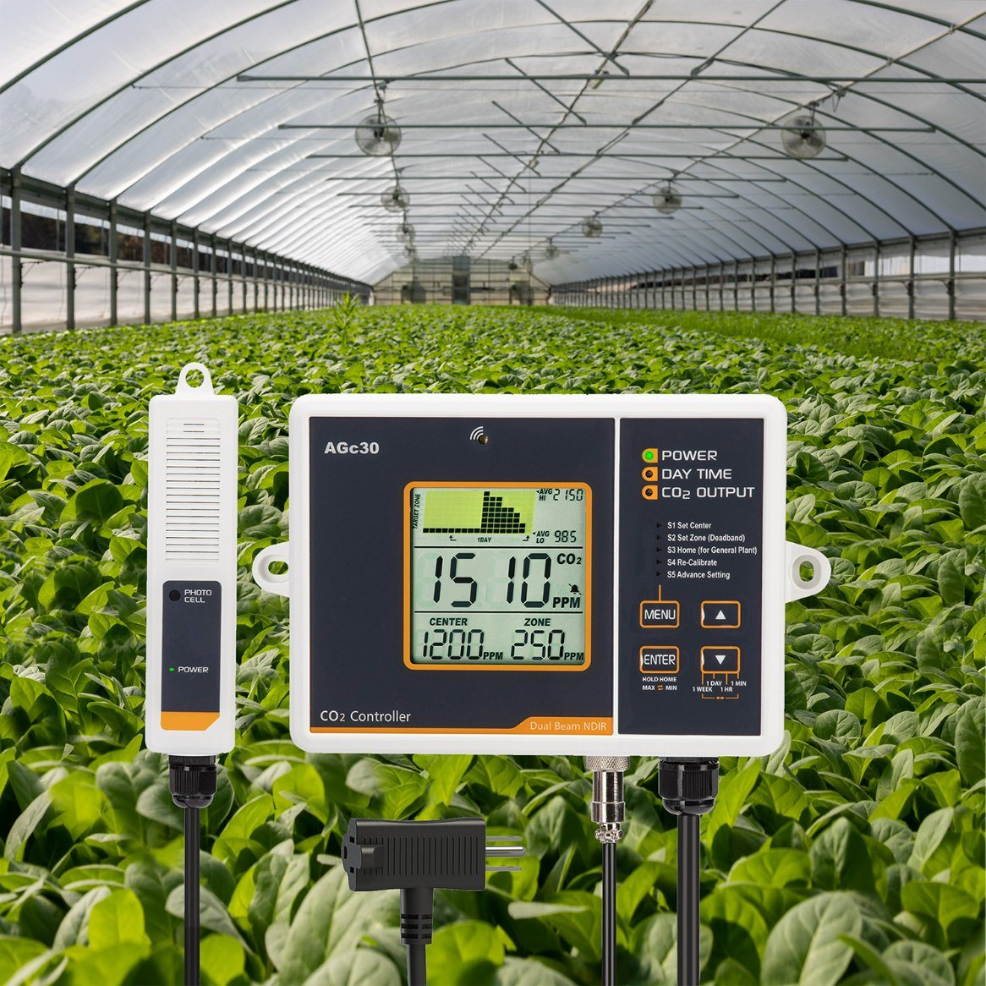

6.Livestock Wearable Sensor:
Definition: Our Livestock Wearable Sensor is a compact device attached to animals to monitor health indicators such as body temperature, heart rate, and movement patterns. It uses accelerometers, thermometers, and GPS technology for comprehensive monitoring.
Use: This sensor provides continuous health monitoring of livestock, alerting farmers to potential issues like illness, stress, or calving. This enables timely interventions and enhances herd management.
Significance: Early detection of health issues in livestock is crucial for preventing disease spread, reducing mortality rates, and improving productivity. Our Wearable Sensor helps farmers monitor their animals effectively, ensuring healthier and more productive herds.

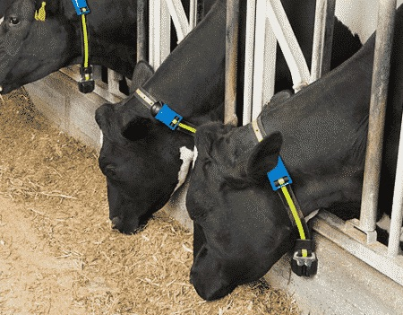
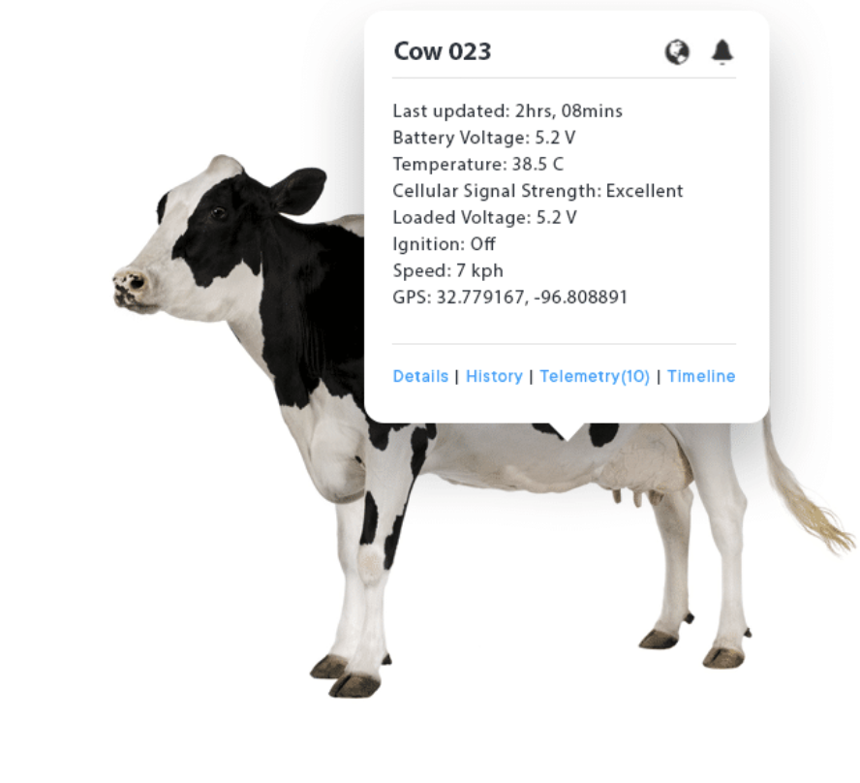

7.Soil Tensiometer

Definition: Our Soil Tensiometer is a sophisticated instrument designed to measure soil moisture tension, providing critical data on how tightly water is held in the soil. It consists of a porous ceramic tip, a sealed tube, and a pressure gauge or sensor that indicates the amount of water tension in the soil.

Use: The Soil Tensiometer helps farmers determine when irrigation is needed by measuring the soil’s moisture tension. When the soil is dry, the tension increases, and the tensiometer provides data that indicates when it’s time to water crops. This tool is essential for managing irrigation efficiently and ensuring that plants receive adequate moisture without overwatering.

Significance: Proper soil moisture management is crucial for optimal crop growth and water conservation. Our Soil Tensiometer enables precise monitoring of soil water availability, helping to avoid both over- and underwatering. By providing accurate readings of soil moisture tension, it supports efficient irrigation practices, reduces water waste, and promotes healthier plants and improved crop yields.

